Name : Alveena Naz
Reg No. FA25-BSE-010
PF LAB
DATE : 3 Nov 2025

Question 1:

import java.util.Scanner;
public class Shape
{
public static void main(String[] args)
{
Scanner input = new Scanner(System.in);
System.out.println(" Enter a String");
String str = input.nextLine();
System.out.println(" Menu : /n" + " 1 : Count and display the total number of vowels in the string.");
System.out.println(" 2 : Count and display the total number of words in the string.");
System.out.println(" 3: Convert the entire string to uppercase and display it.");
System.out.println(" 4: Check whether the string is a palindrome or not.");
System.out.println(" 5: Exit the operation ");
System.out.println(" Enter your choice ");
int choice = input.nextInt();
while(choice!=5)
{
switch(choice)
{
case 1:
int vowels = 0;
for(int i =0; i < str.length(); i++)
{
char ch = str.charAt(i);
char letter = Character.toLowerCase(ch);
if(letter == 'a'||letter == 'e'||letter == 'i'||letter == 'o'||letter == 'u')
vowels++;
}
System.out.println(" The number of vowels in the string is " + vowels);
break;
case 2:
int words = 0;
String word = "";
for(int i =0; i < str.length(); i++)
{
char ch = str.charAt(i);
if(ch!=' ')
{
word+=ch;
}
else
{
words++;
word = "";
}
}
if(!word.isEmpty())
words++;

System.out.println(" The number of words in a string is " + words);
break;
case 3:
String upperLetter = str.toUpperCase();
System.out.println(upperLetter);
break;
case 4:
String reverse = "";
for(int i =str.length()-1; i>=0; i--)
{
char ch = str.charAt(i);
reverse+=ch;

}
if(str==reverse)
System.out.println(" The string is a palindrom");
else
System.out.println(" The string is not a palindrom");
break;
default:
System.out.println(" Invalid choice! Enter a choice between 1 and 5");

}
System.out.println(" Enter another choice for operation");
choice= input.nextInt();
}

}

}

OUTPUT:
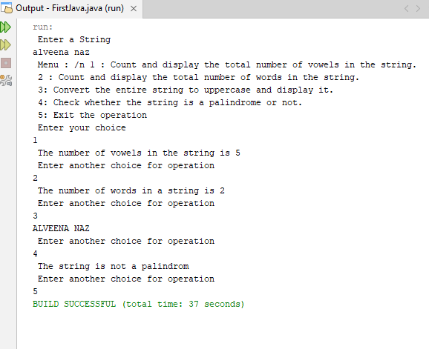

Question 2:

import java.util.Scanner;
public class Shape
{
public static void main(String[] args)
{
Scanner input = new Scanner(System.in);
System.out.println(" Enter three digit integers");
int num = input.nextInt();
System.out.println(" original num " + num);
int sum = num;
int reverse =0;

while(num!=0)
{
int digit = num%10;
reverse = reverse*10 + digit;
num/=10;
}
sum+=reverse;
System.out.println(" The reverse number is " + reverse);
System.out.println(" sum = " + sum);

}
}

Output:
